Amulet Study Guide

pgs. 38-41:

- Know the character (字符): Dr. Weston
- Know about the cure for Mom.
  - What is it?
  - Where is it?

pgs. 42-49:

- Know the character: Leon Redbeard
- What happens at the robot house?
- What do Cogsley and the other robots do?
- Know what happens at the hospital.
  - What does Prince Trellis think?
- Know how everyone escapes (逃走) from the hospital.

pgs. 50-60:

- Who does and doesn’t get on the train?
- How do Emily, Leon, and Miskit hide from the elves?

pgs. 61- 73
- What happens to Emily’s eyes when she uses the amulet?
  - Why?
- Know how Leon wants to help Emily.

pgs. 74- 81
- Who does Navin meet at the underground headquarters?
  - What does the group want?
- Know about Father Adler.
  - What can he do?
  - What does he see?
- What do you think will happen to Emily?

Character | Name | Character | Name
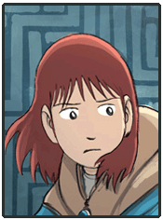 | Emily Hayes | 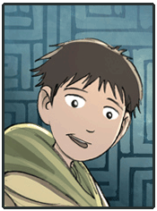 | Navin Hayes
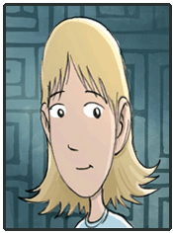 | Karen Hayes (Mom) | 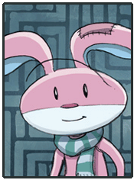 | Miskit
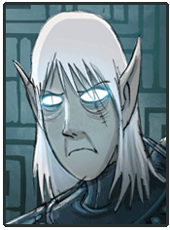 | Trellis |  | Leon Redbeard
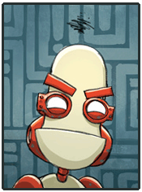 | Cogsley | 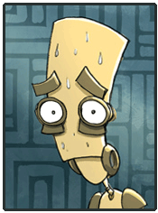 | Morrie
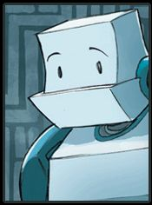 | Bottle | 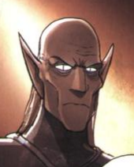 | Luger
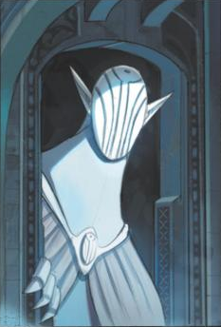 | Elf King

