Amulet Study Guide

pgs. 1-8:

- Know the characters (字符): Prince Trellis, Luger, and the Elf King.
- Look at how Prince Trellis feels. Is he happy, sad, angry, etc.?
- How does the Elf King feel?
- Who is going with Prince Trellis to help catch Emily?

pgs. 9-23:

- Know the characters in the house: Emily, Navin, Miskit, Cogsley, Mom, Morrie, and Bottle.
- What are Navin and Cogsley doing?
- What are Miskit, Bottle, Ruby, and Theodore doing?
- What are Emily and Morrie doing?
- Know the name of the city where they are going.
- Why do they need to go there?

pgs. 24-30:

- Know about the people who live in Kanalis.
- Why are they different (不同)?
- Who is waiting to attack Emily in Kanalis?

Character | Name | Character | Name
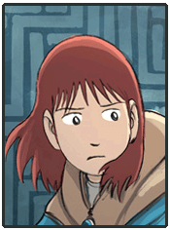 | Emily Hayes | 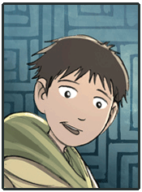 | Navin Hayes
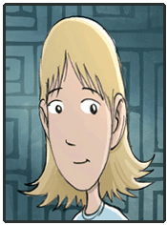 | Karen Hayes (Mom) |  | Miskit
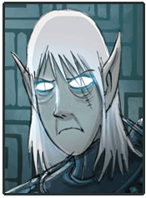 | Trellis |  | Leon Redbeard
 | Cogsley | 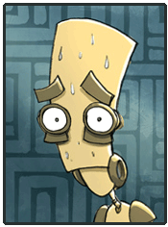 | Morrie
 | Bottle |  | Luger
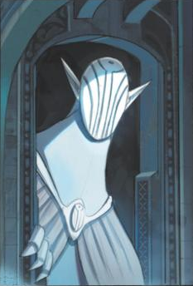 | Elf King

