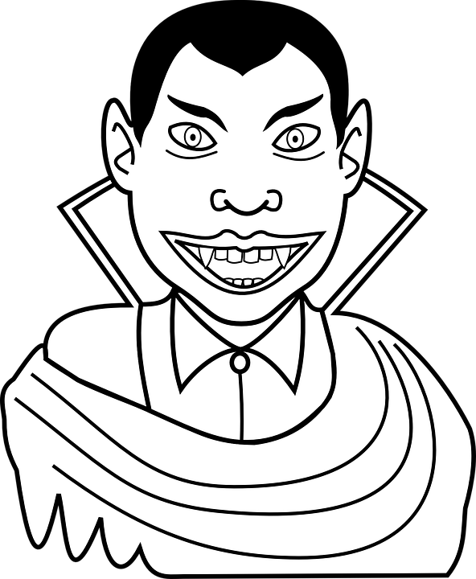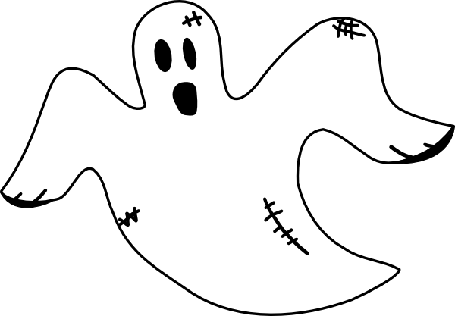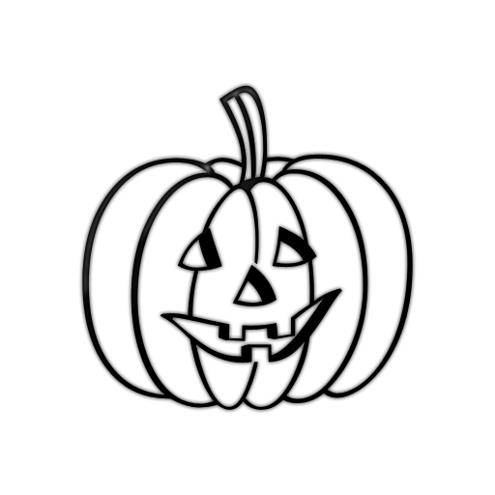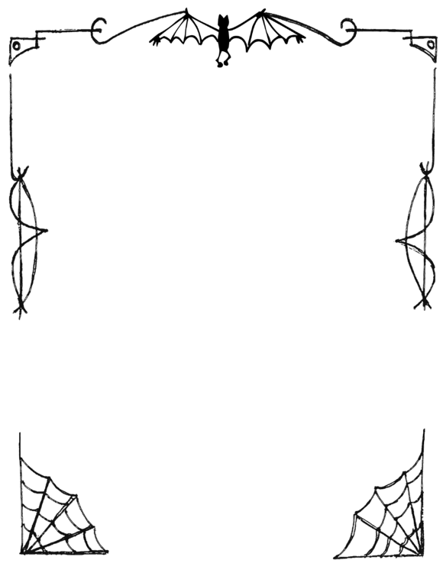

Costumes

* **What are you going to be for Halloween?**
* Wear clothes to look like somebody or something else.
* Vampire- monster that drinks blood. Doesn’t like sunlight and garlic.
* Werewolf- person who changes into a wolf when there is a full moon. Doesn’t like silver.
* Witch- woman that can do magic. Doesn’t like fire.

Trick-or-Treating

* **How do you go trick-or-treating?**
* Walk from house to house wearing a costume.
* Knock on doors and ask for candy.
* Say: TRICK-OR-TREAT!
* Sweets can be anything: chocolate, candy, marshmallow, gummies, etc.

History

* Fall changes to winter.
* Ghosts walk the Earth.
* People would wear masks to trick the ghosts.
* People with no money would go and ask for Soul Cakes.
* Turned into trick-or-treating and costumes in America.

Jack-o-Lanterns

* **How do you carve a pumpkin?**
* CUT off the top.
* CLEAN out the inside.
* CARVE a face or picture.

Halloween